**Cornell Caustic**

**University of Minho**

**Master in Informatics Engineering**

Computer Graphics

Display and Lighting II

June 2016

Bruno Miguel da Silva Barbosa 67646

Carlos Rafael Cruz Antunes 67711

Tomás Moreira Ferreira 67701

**Table of Contents**

Abstract 4

Introduction 4

Experiments 5

Hypotheses 5

Results 6

Path Tracing 6

Adaptive 8

Best Candidate 9

Halton 10

Low Discrepancy 11

Random 12

Stratified 13

Photon Map 14

Adaptive 14

Best Candidate 14

Halton 14

Low Discrepancy 14

Random 14

Stratified 14

Conclusion 14

**Table of Figures**

Figure 1. Default scene, rendered with path tracing. 3

Figure 2. How a caustic shadow is formed. 5

# Abstract

This report explains the entire process of a brief analysis under the subject of Computer Graphics, more specifically about Photorealistic Image Rendering through the Ray Tracing technique. The project was carefully structured in order to easily understand its real purpose. First of all, we start by identifying the actual problem which is, in a few words, the simulation of caustic shadows. Caustics are defined as a group of light rays that are reflected or refracted by curved transparent objects. The next step was planning the experimentation and predict some of the possible results according to each possible approach. Then, it was time to proceed to the rendering experimentation where beyond the final image, it is also taken into account the elapsed time. At last, comes the study of the obtained results and the choice of the best relation between image quality and time spent on it.

# Introduction

This project intends to evaluate different global illumination algorithms’ performance and quality. To do this, the group was given a scene to work with (represented on Figure 1). This image’s resolution is 1024 by 1024 and was rendered using PBRT version 2 (using the surface integrator “path”). The PBRT will also be used to fulfil the purpose of this project by rendering the various experiments. The scene to be studied has various typical surfaces seen on global illumination demos, such as a glossy teapot and ceiling, a mirror, and a crystal-like “killeroo” model. Our particular focus will be on the “killeroo” model, by trying to get the best caustic shadow possible.

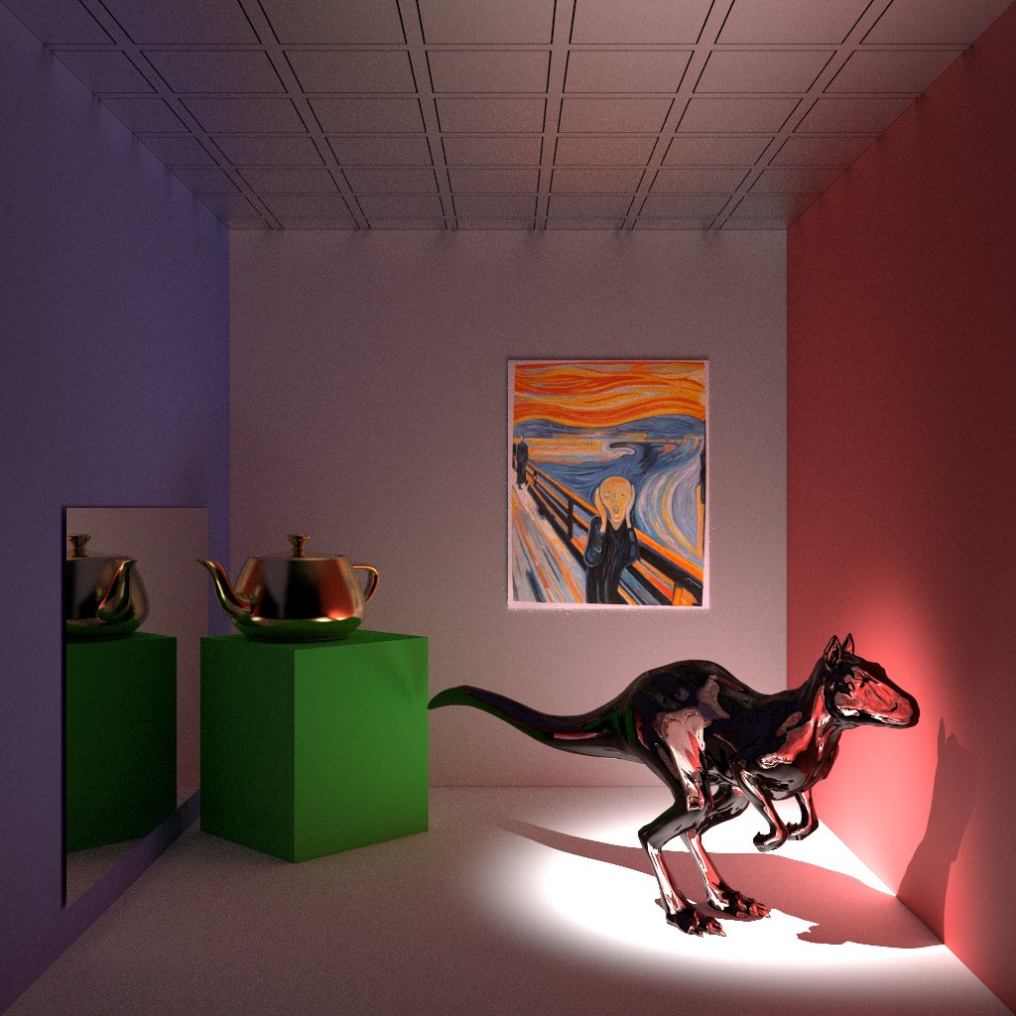

Figure 1. Default scene, rendered with path tracing.

# Experiments

In order to achieve the best result, and have a basis for comparison, some surface integrators and samplers to test were selected. Each surface integrator is tested with a different sampler. The planned elements are shown on Table 1.

Table 1. Planned experiments.

|  |  |
| --- | --- |
| Surface Integrators | Samplers |
| Path | Adaptive |
| Photon Map | Best Candidate |
|  | Halton |
|  | Low Discrepancy |
|  | Random |
|  | Stratified |

The result of each connection should generate an image and the time it took to render, for example, the path surface integrator with an unknown sampler generated Figure 1, which as given to the group to present the scene. The imagens to be rendered will have a width and a height of 800 pixels. The samplers’ “pixelsamples” argument will be 256, at the exception of the adaptive (“minsamples” set to 128 and “maxsamples” set to 256) and stratified samplers (“xsamples” and “ysamples” set to 16, with jitter). The Photon Map surface integrator receives the argument “causticphotons” as 10.000 and the “indirectphotons” as 20.000.

# Hypotheses

Caustics are the consequence of light rays being focused in specific regions as a result of refraction (light rays passing through the “killeroo” model on this case). In the current case study, it is believed that the photon map surface integrator will produce a better result than the rest. This is simply because the path tracing is unable to produce a caustic, due to its random nature, when a ray hits a point that should be a caustic, a random ray is generated, and the probability of this ray being on the right direction (the “killeroo” model) is very low (shown in Figure 2 as red rays). And so the caustic would be no more than a normal shadow using path tracing. The photon map, on the other hand, is the ideal algorithm for this scene, and can generate very realistic caustics.

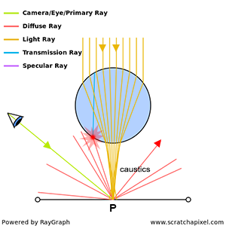

Figure . How a caustic shadow is formed.

# Results

On this section will be displayed all the images obtained, such as their rendering time. On Graph 1 is shown a global comparison between surface integrators and samplers.

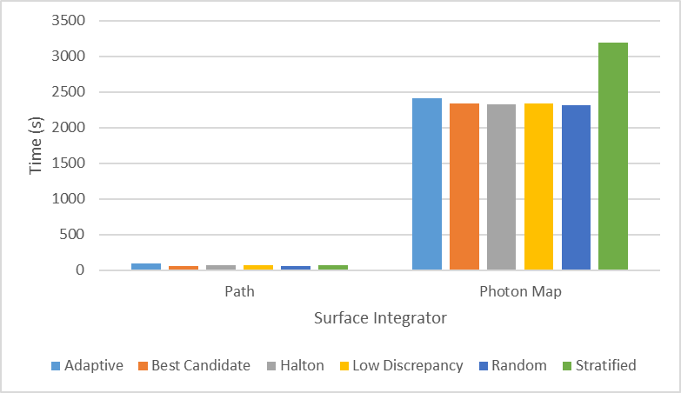

Graph . Global comparison between the studied algorithms.

## Path Tracing

This subsection is dedicated to the experiments with path tracing. On Graph 2 is displayed the rendering time of the images produced. It can be verified that the elapsed time was similar with a peak on the adaptive sampler.

As we are going to see in the next sections, due to the nature of this exact surface integrator, the resultant images have a lot of noise, specially on non-direct lighted surfaces as well as on shadows. By the way, we didn’t already achieve the goal of this work. It isn’t impossible to simulate caustics with Path tracing, however we are limited by two big issues: number of rays shoot and the randomness of the direction of news rays.

More rays mean more accuracy, precision and quality but it traduces on a huge increment on the rendering time. By the other hand, caustics are a unique light effect and the randomness of rays’ direction can make things much harder, once they could not go to where they should be.

Graph . Rendering time comparison between samplers using the path tracing surface integrator.

### Adaptive

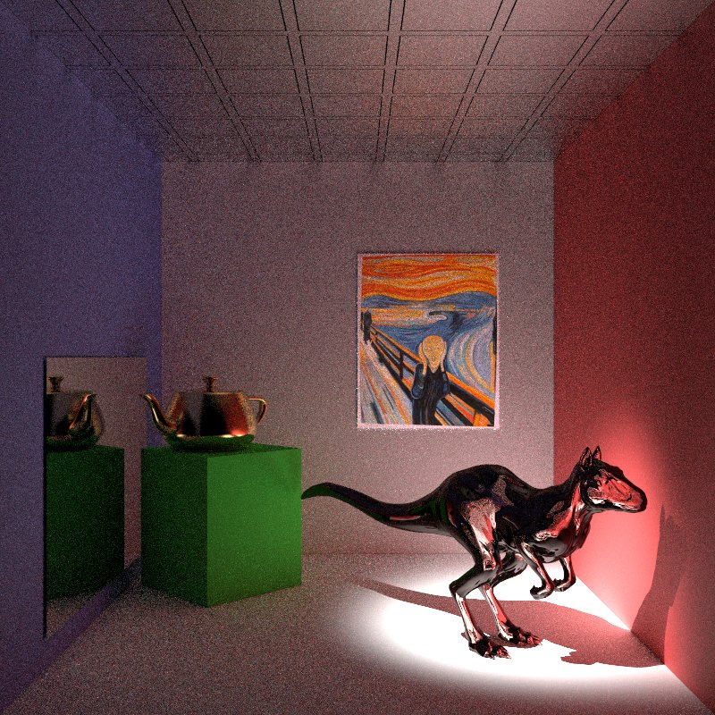

Figure . Scene rendered with path tracing and an adaptive sampler.

### Best Candidate

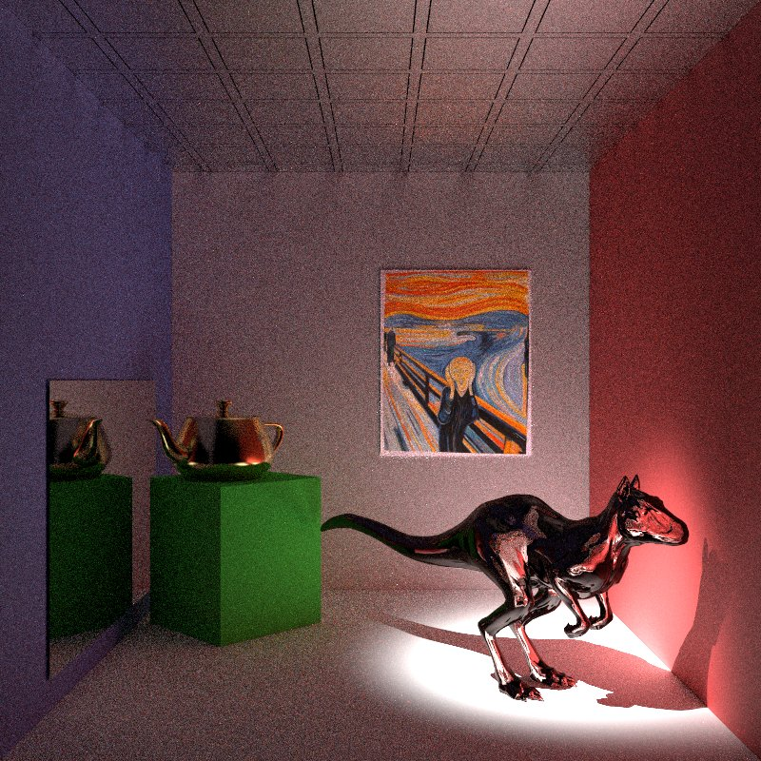

Figure 4. Scene rendered with path tracing and a best candidate sampler.

### Halton

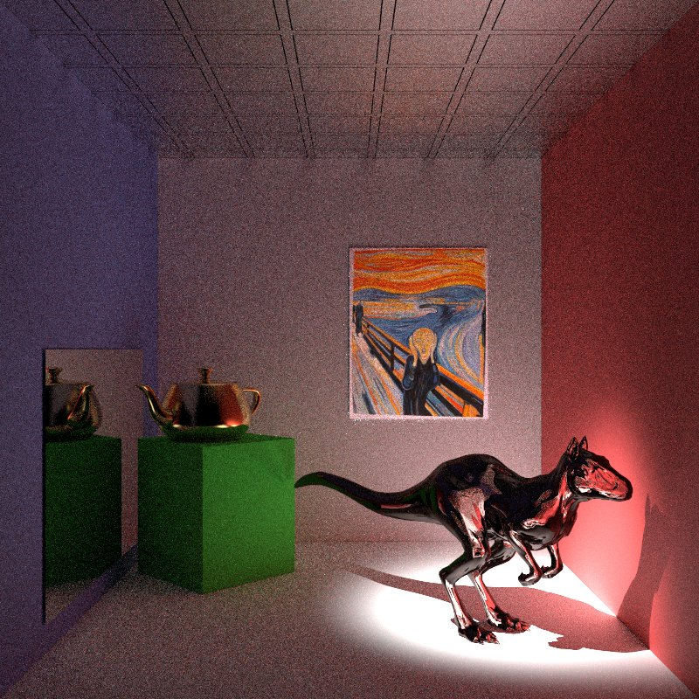

Figure 5. Scene rendered with path tracing and a halton sampler.

### Low Discrepancy

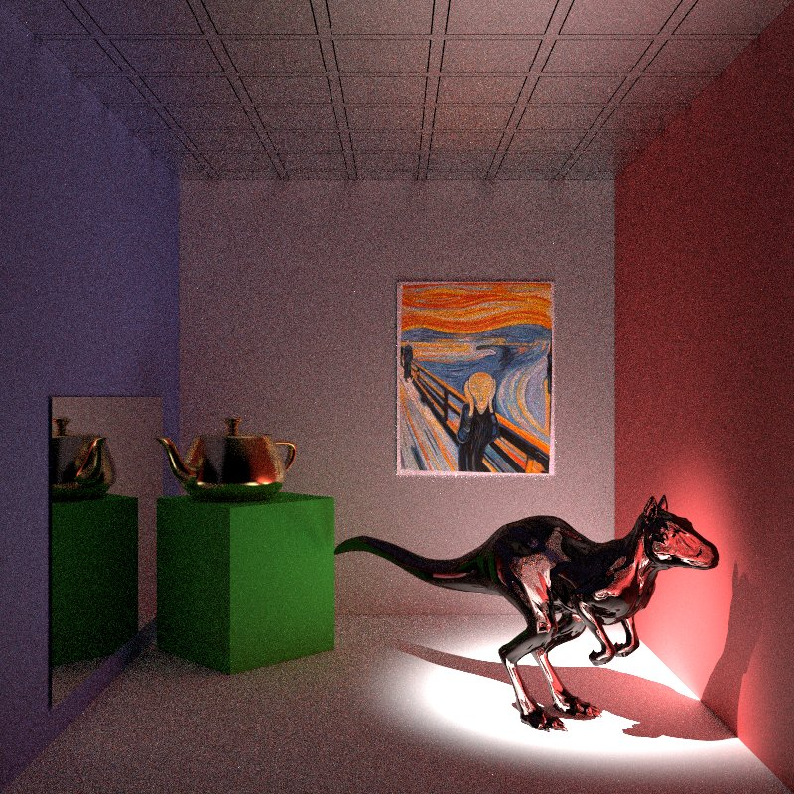

Figure 6. Scene rendered with path tracing and a low discrepancy sampler.

### Random

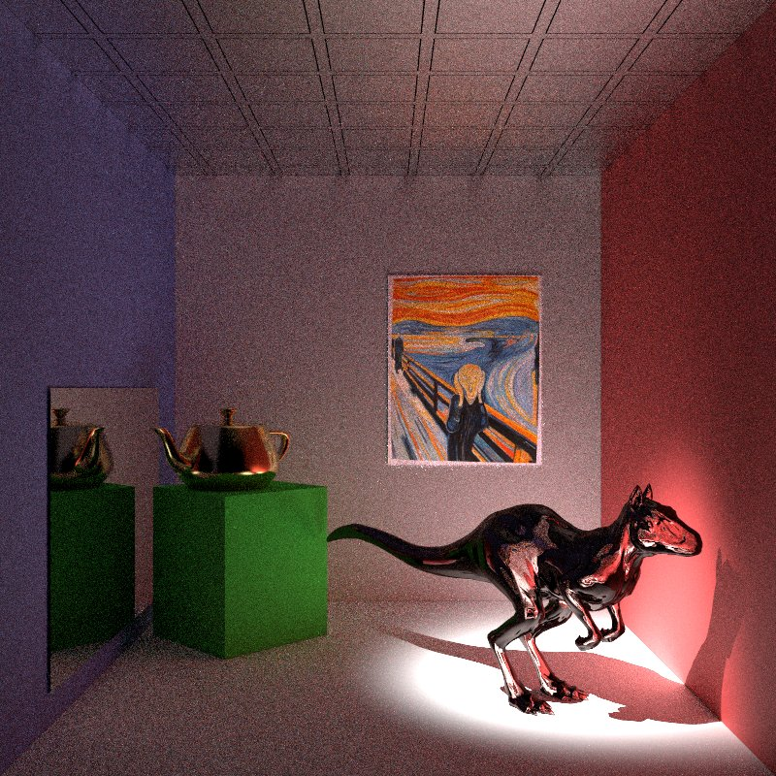

Figure 7. Scene rendered with path tracing and a random sampler.

### Stratified

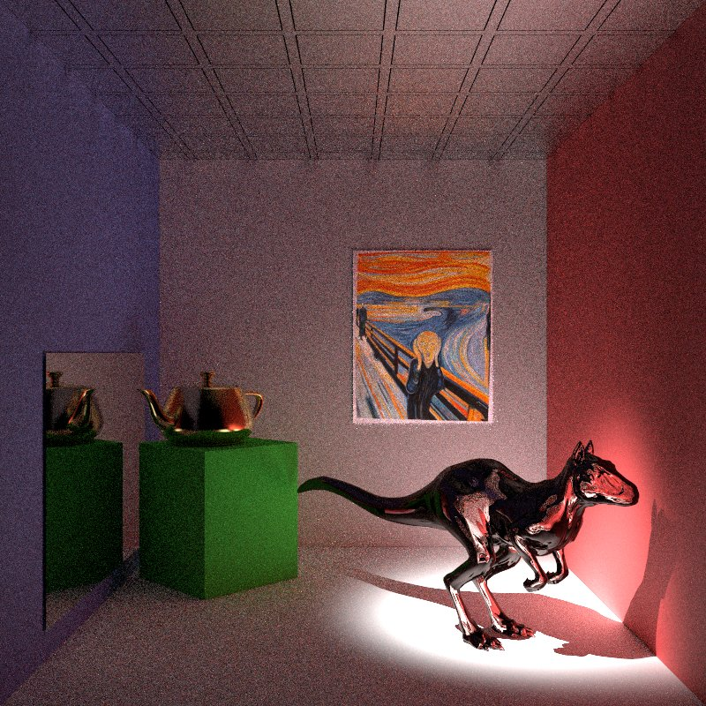

Figure 8. Scene rendered with path tracing and a stratified sampler.

## Photon Map

From Graph 3 we also see that, in general, rendering times are very similar for all samplers. In this particular case, the outlier goes to the Stratified sampler. Comparing with the times got for Path tracing, we identify a significant increase. Photon Map rendering time is, in most cases, about 60 times bigger. Nevertheless, we can see some caustics yet even as some undesired artifacts.

The images’ quality is clearly better…

Graph 3. Rendering time comparison between samplers using the photon map tracing surface integrator.

### Adaptive

### Best Candidate

### Halton

### Low Discrepancy

### Random

### Stratified

# Conclusion

* espirito critico!
* trade of entre X e Y
* refletir sobre os resultados obtidos e porque